Computer Language Coding Concepts

Interface Inheritance
Since any redirection of a triangle is considered inheritance, interface redirection of a triangle may also be called inheritance: interface inheritance.

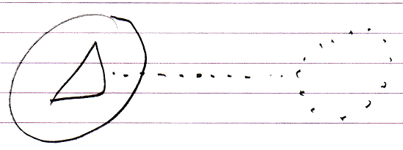

So the main concept of inheritance is basically the same as that of interfaces.

Author & Copyright: Jan-Joost van Zon Date: May 18, 2010 – July 17, 2010 Location: Oosterhout, The Netherlands Status: Finished

